**Reports**

**Counting No of Males and Females**

declare @male_count as int;

declare @female_count as int;

set @male_count = (select count(*) as male_count from census.residents where sex='m')

set @female_count = (select count(*) as male_count from census.residents where sex='f')

select @male_count as Male_count, @female_count as Female_count

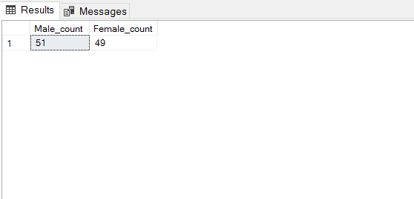

**Region assigned for employees**

select concat(firstname, lastname) as emp_name, position, regiondesc

from census.employees, census.assignments, census.regions

where [census].[Assignments].employeeid = [census].[Employees].employeeid and [census].[Assignments].regionid = [census].[Regions].regionid

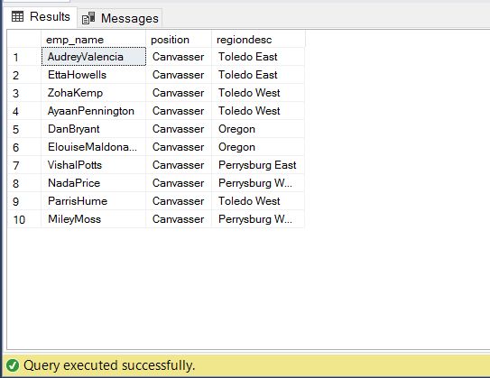

**Calculating Age of residents**

select concat(firstname, middlename, lastname) as name, datediff(yy, census.residents.dob, getdate()) as age from census.residents

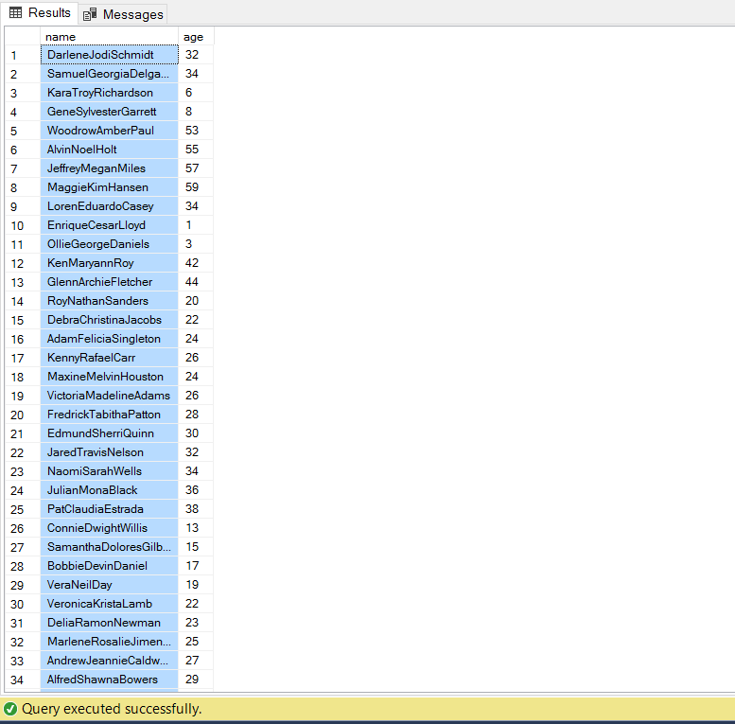

**No of Children, babies, infants and adults**

declare @infants as int

declare @baby as int

declare @child as int

declare @adult as int

set @infants = (select count(*) from census.residents where datediff(yy, census.residents.dob, getdate()) <= 1)

set @baby = (select count(*) from census.residents where datediff(yy, census.residents.dob, getdate()) > 1 and datediff(yy, census.residents.dob, getdate()) <=4 )

set @child = (select count(*) from census.residents where datediff(yy, census.residents.dob, getdate()) > 4 and datediff(yy, census.residents.dob, getdate()) <=18 )

set @adult = (select count(*) from census.residents where datediff(yy, census.residents.dob, getdate()) > 18 )

select @infants as infant, @baby as baby, @child as child, @adult as adult

